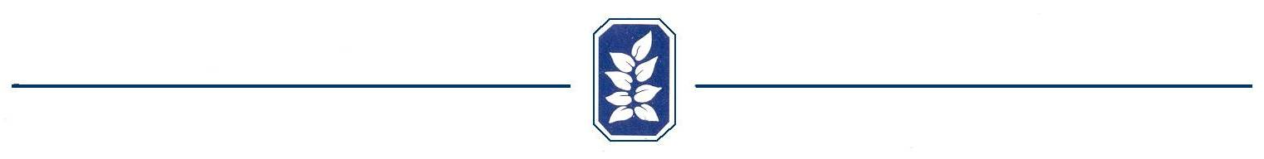


Clubhouse Rental Checklist

The below is a list of requirements that must be completed after your rental in order to qualify to get back your rental deposit. If upon you first entering the clubhouse you note any damage or that any of these conditions are not met by previous occupants, please report it immediately with photos if necessary to www.Clubhouse@OldMillHOA.com to avoid you being held responsible. After your rental, please initial each item as you complete them, sign where indicated and leave on counter in clubhouse. Items not checked-off may be assumed as not completed. If any of these are found not completed after your rental, your deposit will be cashed and you will be charged up to $25 for each item listed below not completed. The balance of your deposit, if any, will be returned.

_____ All garbage must be placed in garbage cans and the cans placed in the area next to
the dumpster in the parking lot, including any large garbage cans in the pool area
with garbage in them. A new trash bag must be placed in the trashcan inside the clubhouse.

_____ Kitchen counters and sink wiped down and left clean.

_____ Refrigerator and microwave emptied and cleaned.

_____ Tables and chairs cleaned and neatly returned to closet where indicated by signs.

_____ Take down and remove party decorations. No sign of tape, push pins, tacks or decorations left on walls. Damage from decorations must be repaired.

_____ Floors swept and mopped.

_____ Close all blinds.

_____ Turn air up to 80 in the summer and heat down to 60 in the winter.

_____ Turn off ceiling fan and ALL lights, including outside lights.

_____ Lock all doors except door in back hallway leading to bathrooms from the outside pool area during pool season only.

_____ Leave the checklist on the counter in the clubhouse.

_____ Lock the clubhouse front door by pushing the “Lock Symbol” on the touch pad.

_____ Leave one table and one chair set up under the TV.

I understand that if all of the above items are not completed, I risk forfeiting my deposit.

Old Mill Home Owner/Renter’s Signature: _____________________________________

Please Print______________________________________________________________

Date: __________

