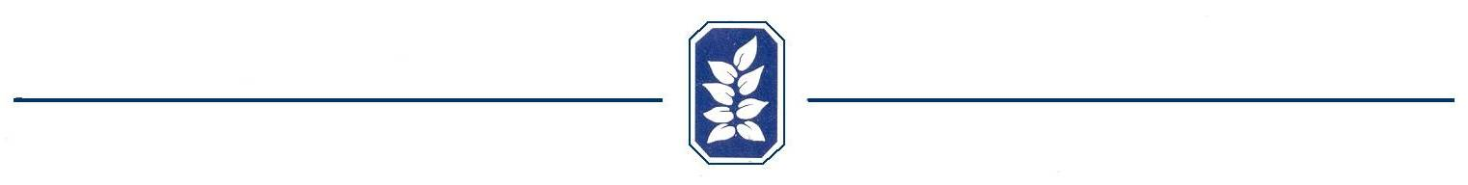

Good Neighbor Form – Connect to Fencing

Sometimes in an effort to increase the beauty of a fence, decrease the cost of installation or make installation easier or stronger, a homeowner may want to connect his fence to the adjoining property’s existing fencing.

As a courtesy to our neighbors that have existing fencing we have developed this form to ask for, and document, permission to connect new fencing from one homeowner to the existing fencing of an adjoining neighbor.

The Architectural Control Committee must still make a determination if the fence will influence the appearance of the community in a negative manner before approval will be given.

This form, by no means, insures that a fence can be constructed by the homeowner without the Architectural Control Committees review and approval of the plan. Its purpose is to simply give the homeowners a form as a convenience when requesting that consent from their neighbor(s).

Lot or Address Requesting Connection _____________________________

Homeowner’s signature _______________________________________

We give our consent to the above homeowner to connect a fence between our property and theirs.

Neighboring Lot Number or Address __________________________________
Left _____ Right_____ Rear_____ Rear Far Right_____ Rear Far Left____

Homeowner’s Signature _________________________________________

Neighboring Lot Number or Address __________________________________
Left _____ Right_____ Rear_____ Rear Far Right_____ Rear Far Left____

Homeowner’s Signature _________________________________________

Neighboring Lot Number or Address __________________________________
Left _____ Right_____ Rear_____ Rear Far Right_____ Rear Far Left____

Homeowner’s Signature _________________________________________

