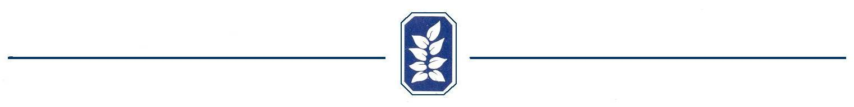

Good Neighbor Form – Good Side In

The standard that was established by the developer of Old Mill subdivision in reference to fencing cross rails and posts is that the “good side” or “pretty side” should face out on all sides. In the unique instance that a homeowner requests a fence approval with “good side” in, that homeowner must have the homeowner of the adjoining affected lots give written consent to break with the standard. The Architectural Control Committee must still make a determination if the fence will influence the appearance of the community in a negative manner before approval will be given. All fences must be “good side” out on portions facing the street with no exceptions.

This form by no means insures that a fence can be constructed by the homeowner with “good side” in without the Architectural Control Committees review and approval of the plan. Its purpose is to simply give the homeowners a form as a convenience when requesting that consent from their neighbor(s).

Lot or Address Requesting “Good Side” In _____________________________

Homeowner’s signature _______________________________________

We give our consent to the above homeowner to build a fence between our property and theirs with the posts and rails facing our lot and the “good side” facing theirs.

Neighboring Lot Number or Address __________________________________
Left _____ Rear_____ Right_____

Homeowner’s Signature _________________________________________

Neighboring Lot Number or Address __________________________________
Left _____ Rear_____ Right_____

Homeowner’s Signature _________________________________________

Neighboring Lot Number or Address __________________________________
Left _____ Rear_____ Right_____

Homeowner’s Signature _________________________________________

