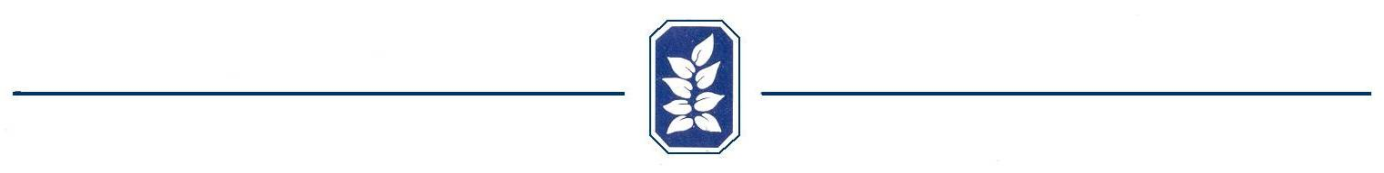


Fence Submittal Form

Name: _____________________________ Lot Number: ________________

Address: ___________________________ Phone Number: ______________

Email Address: ___________________________

Material Type Iron Wood* Other __________________

Color: Natural Painted Stained Color (if Applicable)______________

*If wood please complete the following information:
*Type of wood (cedar, pine, etc.): ________________________________________
*Fastening material Nails Screws Other __________________
*Number of horizontal support rails: Three Other __________________

Are there any existing fences around the perimeter of the property? Yes No
Will the primary purpose of this fence be to contain pets? Yes No

Please attach a drawing of the proposed fence. Be sure to include property lines, home outline, fence boundaries, servitudes, approximate dimensions, and the position of gate(s).

Use the following space to give a brief explanation of the drawing(s). Attach additional sheets if necessary.

________________________________________________________________________
________________________________________________________________________
_______________________________________________________________________
________________________________________________________________________

If fencing within servitude, the fence must not impede drainage of your lot or surrounding lots. This is in accordance with Article I, definition #19 of the Old Mill Covenant. Furthermore, the Parish of Ascension maintains the right that any fence within the servitude is subject to removal without any prior notification by the parish and will not be held responsible for expense or replacement of the structure.

By signing below, I understand that the Old Mill Architectural Committee has 30 days from the date received to review and respond to this submission. It also gives the committee the right to review the proposed site of the fence. Any changes of the plans by the homeowner must result in an additional submittal. This submittal is strictly for this specific lot and is not implicit of the same improvements being made to other lots without additional approvals. All city, parish, and state codes must be adhered to during all phases of construction.

Signature: _______________________________________ Date: ______________________

Received by: _____________________________________ Date: ______________________

