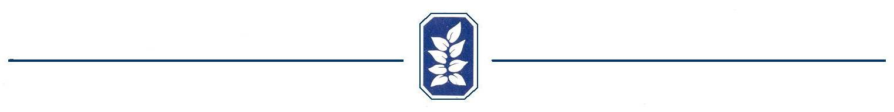

Clubhouse Reservation Agreement

Homeowner Information
Printed Name: ___________________________________________________
Address: ________________________________________________________
Telephone Number: _______________________________________________
E-Mail Address: __________________________________________________

- The Homeowner agrees to "Hold Harmless" Old Mill Subdivision Homeowners Association Members and its Board of Directors should any accident or injury occur to the homeowner or its guests during the use of the clubhouse and other facilities.

- The Homeowner and its guests will have sole use of the clubhouse during the rental period, but will share use of the swimming pool and playground with other Homeowners that may also be present.

- The Homeowner agrees to be responsible for its guests and must be present with its guests during the entire time stated above.

- The clubhouse, pool area, and playground are NON SMOKING facilities.

- The only cooking allowed in the clubhouse is by using the microwave.

- Only push pins or tacks may be used on the walls to hang decorations. Tape of any kind is not allowed on the walls.

- If there is any permanent damage done, the Homeowner will have the option of repairing it or forfeiting the damage deposit. If the damages exceed the amount of the deposit, the Homeowner will be responsible for the balance. Please inspect and report any existing clubhouse damages to the Clubhouse Committee and HOA President upon arrival.

By signing this agreement, I understand the above terms and acknowledge that this form will be kept on file for future rentals and I may forfeit my rental deposit if said terms are not followed.

__________________________________________
Owner's Signature

